Help the cities of Oakridge and Westfir plan for the future
No matter if you are a renter or looking to own, housing in Oregon is becoming less affordable, available, and attainable. Providing an adequate and affordable range of housing types is a priority for the cities of Oakridge and Westfir.

Your responses to this short (~5min) survey will help to prioritize how we plan for the future.

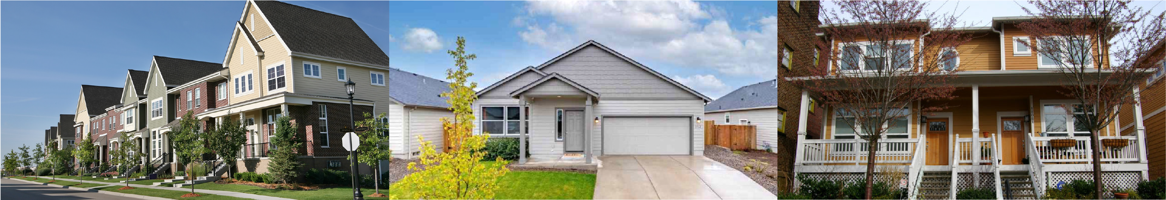
- In regards to homeownership, what do you think are the biggest issues related to housing in Oakridge/Westfir? (Choose up to 3):
  - Lack of homes on the market
  - Lack of affordable ownership options
  - Lack of options for first time homebuyers
  - Lack of land available for housing development
  - Lack of different types of housing options to purchase (such as homes on smaller lots, townhomes, etc.)
  - Lack of options for downsizing/older adults
  - Other:

- In regards to Rentals, what do you think are the biggest issues related to housing in Oakridge/Westfir? (Choose up to 3):
  - Lack of rentals on the market
  - Lack of affordable rental options
  - Lack of land available for new multifamily housing development
  - Lack of options for downsizing/older adults
  - Lack of options for seasonal/workforce housing
  - Other: _________

- What are your concerns related to meeting the housing needs of current and future residents? (Choose up to 3)
  - Lack of land available for housing development
  - Lack of choices of housing types and sizes (single-family, duplex, townhome, apartment, accessory dwelling)
  - Lack of housing that is affordable
  - Lack of development/new construction
  - I have no concerns
  - I’m not sure
  - Other:

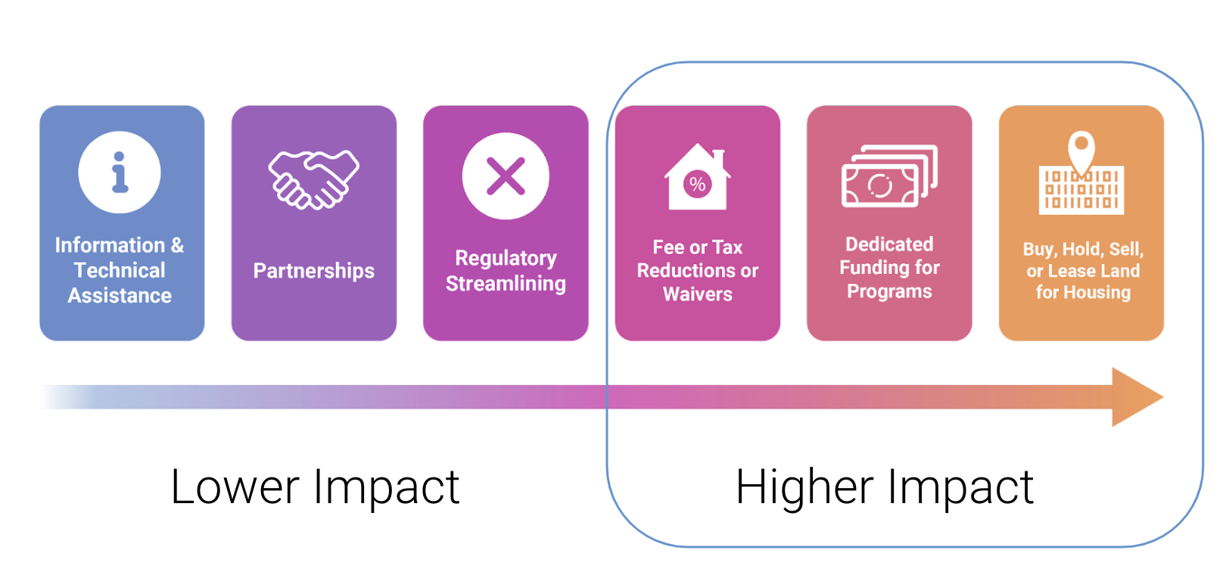
- What are some things the cities of Oakridge or Westfir can do to help meet the housing needs of future residents?
  - Encourage mixed-use development in the downtown area.
  - Provide infrastructure (water, sewer, and roads) to create new planned unit developments or single-family subdivisions
  - Create additional opportunities for middle housing types, such as duplexes, townhomes, and apartments
  - Dedicate resources to affordable housing development
  - Improve the speed/efficiency of the permitting process
  - None of the above
  - Other:

- Do you have any other comments about current and future housing needs in Oakridge or Westfir?

DEMOGRAPHICS QUESTIONS (OPTIONAL)
It’s important for us to understand who we’re hearing from (or not) so that we can continue to do better outreach in the future. Please tell us a bit about yourself.
- How old are you?
  - Under 18
  - 18-29
  - 30-39
  - 40-49
  - 50-59
  - 60-69
  - 70+
  - Prefer not to answer

- How would you describe your race and ethnicity? (Mark all that apply)
  - White or Caucasian
  - Black or African American
  - Hispanic or Latino
  - Asian or Asian American
  - American Indian or Alaskan Native
  - Native Hawaiian or other Pacific Islander
  - Another race
  - Prefer not to answer

- How do you identify?
  - Female
  - Male
  - Non-binary
  - Prefer not to answer
  - Prefer to self-describe:

- Do you rent or own the house you’re currently living in?
  - Rent
  - Own
  - Other:

Thank you for taking this survey!
We appreciate your time and input. Please submit this survey to Oakridge City Hall by October 2, 2022.

For questions or to learn more about the Housing Needs Analysis project, please contact:
James Cleavenger, City Administrator
cityadministrator@ci.oakridge.or.us
(541) 782‑2258

