Oakridge Geothermal Heat & Energy Opportunities
The area surrounding Oakridge is renowned for its geothermal activity, a testament to the region's rich geological heritage. This area was once a base for two popular hot springs resorts, Kitson Hot Springs and McCredie Hot Springs, which attracted visitors for decades. McCredie Hot Springs, despite the resort no longer being operational, continues to be a favored destination for day visitors. Similarly, Wall Creek warm springs was a popular spot before the Cedar Creek fire.

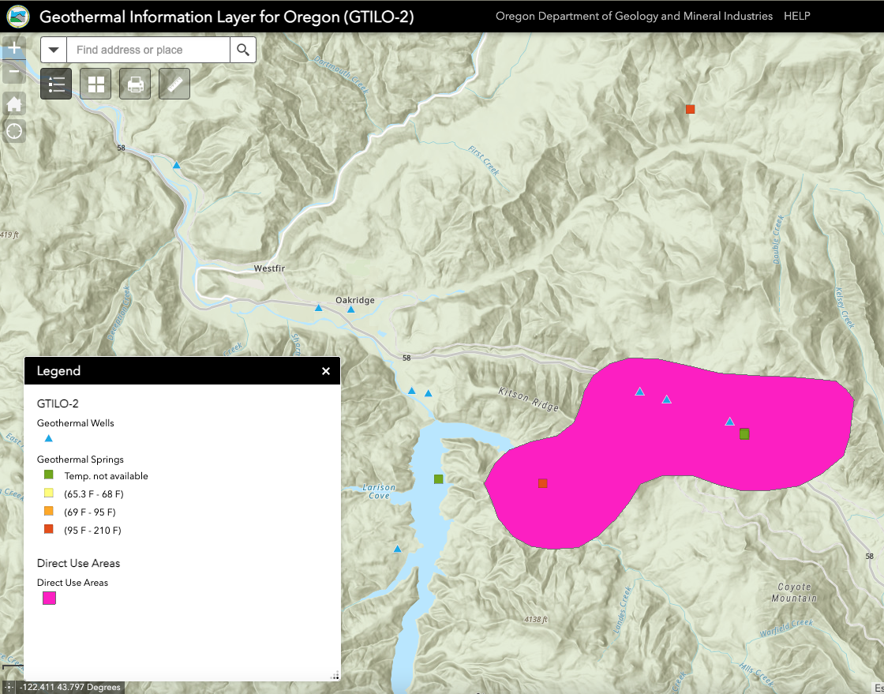
Oakridge, situated amidst this geothermal-rich landscape, is uniquely positioned to explore and potentially harness this renewable energy source, further enhancing its reputation as a hub for natural and sustainable resources. There remains common knowledge at the City that two geothermal wells were explored in the early 1990s, including one located in the Oakridge Industrial Park. It was determined at that time that there was not necessarily enough heat for development, but technology has greatly improved since then.

Geothermal hot springs and wells near Oakridge according to the Oregon GIS maps provided by the Department of Geology and Mineral Industries (DOGAMI)

A new feasibility study to reevaluate the City of Oakridge's two thermal wells could assess their potential for geothermal energy utilization. This study would provide crucial insights into the viability of harnessing the Earth's natural heat from these wells for sustainable energy production. By evaluating factors such as the wells' temperature, flow rate, and the local geological conditions, the study would determine the practicality and economic viability of developing a geothermal energy system. This could pave the way for Oakridge to tap into a renewable and efficient energy source, marking a significant step towards environmental sustainability and energy independence.

Small-scale geothermal energy systems harness the Earth's natural heat for heating and cooling purposes. Unlike large-scale geothermal power plants that require specific geological conditions, small-scale geothermal systems can be implemented in a wide range of locations.
Here are some key aspects of small-scale geothermal systems:

Types of Systems: The most common small-scale geothermal systems are ground-source heat pumps (GSHPs). These systems use the stable temperature of the ground (typically between 50-60°F or 10-15°C year-round) as a heat source in winter and a heat sink in summer.

How They Work: GSHPs consist of a series of pipes, called a loop, buried in the ground near the building. A fluid (water or a water-antifreeze mixture) circulates through these pipes, absorbing heat from the ground in winter and transferring it into the building. In summer, the process is reversed, and the system extracts heat from the building and dissipates it into the ground.

Efficiency: Small-scale geothermal systems are highly efficient for heating and cooling. They use less energy compared to traditional HVAC systems because they merely transfer heat rather than generate it. This efficiency can result in significant cost savings over time.

In summary, small-scale geothermal systems offer an efficient, sustainable, and cost-effective solution for heating and cooling and in some cases, for generating electricity. While the initial installation cost can be high, the long-term benefits and low environmental impact make them an attractive option for residential and small commercial applications.

DOE Federal Energy Funding for Rural and Remote Areas: A Guide for Communities:

www.energy.gov/sites/default/files/2023-10/OCED_Rural-Remote%20Fed%20Overview.pdf?mc_cid=ff86fb588a&mc_eid=be2853a59c

