Opportunities for Oakridge Micro Hydro Energy Projects

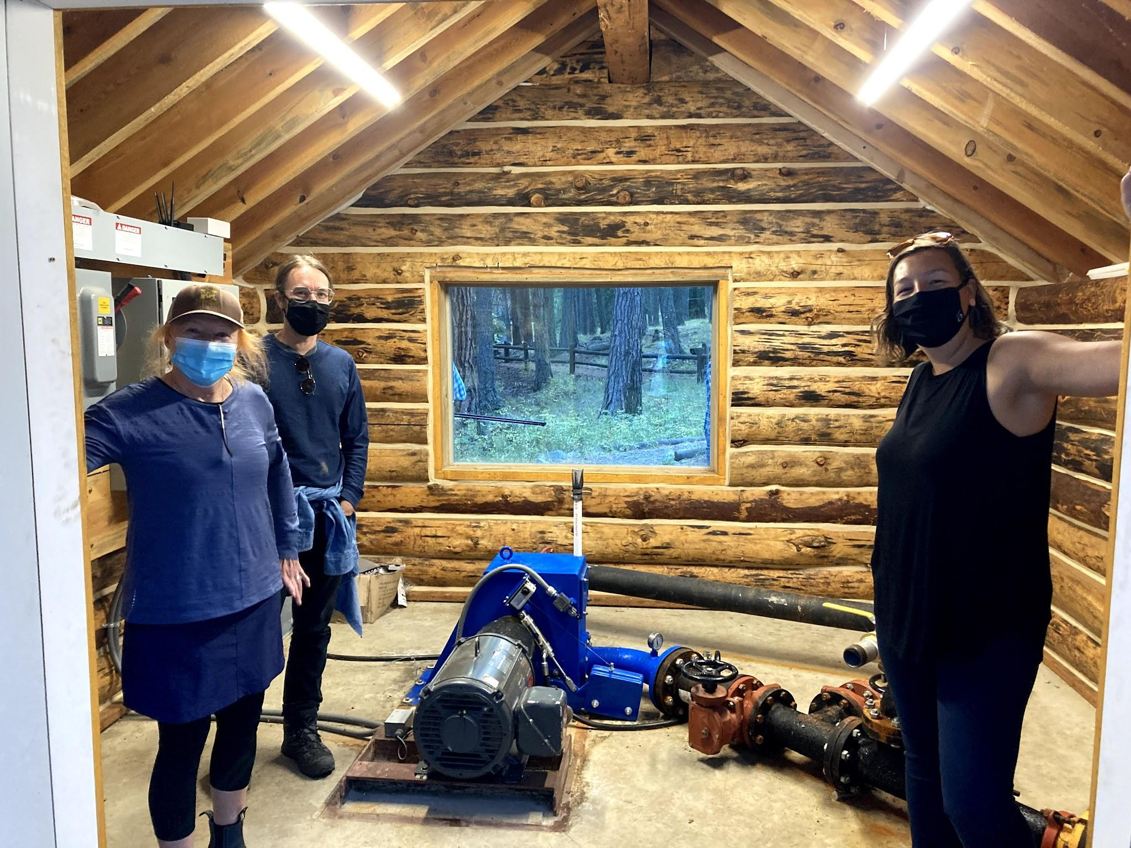
Oakridge, a city rich in natural resources and beauty, presents a remarkable opportunity for sustainable energy generation through micro hydro projects. The city's water towers, the natural springs on Laurel Butte, and the old canal trail each offer unique potential for harnessing the power of flowing water. These sites, with their varying topographies and water flows, are ideal for the development of micro hydro systems that could provide clean, renewable energy to the community. By tapping into these local resources, Oakridge has the opportunity to become a leader in small-scale hydroelectric power, demonstrating how communities can utilize their natural landscapes for environmental and economic benefits.

Micro hydro is a type of hydroelectric power that typically produces up to 100 kilowatts of electricity using the natural flow of water. It's considered a "micro" version of the larger hydroelectric power systems found in dams. See the attached summary of a micro hydro project at Wallowa Lake that cost less than $500,000 to develop.
SWS board member Laurie Patty and Oakridge RARE members Dustin Rymph and Grace Kaplowitz turbine micro hydro station at Wallowa Lake.

Here are some key points about micro hydro systems:

1. Small-Scale Energy Production: Micro hydro systems are much smaller than traditional hydroelectric power plants. They are suitable for small communities, rural areas, or individual homes, often in remote locations where other means of power generation are not viable or too expensive.

2. Environmentally Friendly: One of the main advantages of micro hydro systems is their minimal environmental impact compared to large-scale hydroelectric power.

3. Use of Natural Water Flow: Micro hydro systems harness the energy of flowing water from streams, rivers, or man-made channels. The water flow turns a turbine, which then drives a generator to produce electricity.

4. Efficiency and Reliability: These systems can be highly efficient and reliable, especially in areas with consistent water flow. They can generate power continuously, as opposed to solar or wind power, which depend on weather conditions.

5. Cost-Effective: Although the initial setup cost can be significant, the ongoing operation and maintenance costs are relatively low. Additionally, micro hydro systems have a long lifespan, which can make them a cost-effective solution over time.

6. Community Development and Energy Independence: By providing a local and sustainable source of energy, micro hydro systems can foster community development and energy independence, especially in remote or off-grid areas.

These locations in Oakridge offer unique opportunities for micro hydro:
Map of city owned infrastructure including the Oakridge industrial park, city water towers, and
the Old Mill Canal
from Salt Creek.
City Water Towers
The City of Oakridge's ownership of two water towers located on Laurel Butte and TV Butte presents a unique opportunity for the implementation of micro hydro projects. These water towers, which utilize the principle of gravity to feed water into the city, are ideally suited for micro hydro for several reasons:

Elevation and Gravity: The key to the potential of these sites lies in their elevation. Being situated on buttes, the water towers are at a higher altitude relative to the city. This elevation difference creates a natural gravitational force, which causes the water to flow downwards with significant force and speed. In micro hydro systems, this natural flow can be harnessed to turn turbines and generate electricity.

Consistent Water Flow: Since these water towers are integral to the city's water supply system, they likely maintain a consistent flow of water. For micro hydro systems, a steady and predictable flow is crucial for ensuring a reliable and continuous generation of power.

Existing Infrastructure: The current infrastructure for water distribution from these towers can be advantageously integrated with micro hydro technology. This means potentially lower initial setup costs and less environmental disruption than building new structures or systems.

Energy Efficiency and Sustainability: By installing micro hydro systems at these sites, the city can convert an essential service - water distribution - into a dual-purpose system that also generates clean, renewable energy. This approach can significantly improve the overall energy efficiency of the city's infrastructure.

Reduced Transmission Losses: Generating electricity at or near the point of use - in this case, within the city limits - minimizes energy losses that occur during long-distance transmission. This makes the energy production more efficient and cost-effective.

Community and Environmental Benefits: Implementing micro hydro projects at these sites could provide Oakridge with a sustainable and local source of energy, reducing reliance on external power sources and contributing to environmental conservation.

Old Mill Canal
The City of Oakridge's ownership of the Old Mill Canal, along with a water right at Salt Creek, opens up another valuable opportunity for the implementation of micro hydro stations. This strategic asset could be transformed into a sustainable energy source while also addressing environmental concerns in the area. Here's how:

Piping the Canal: By installing pipes along the Old Mill Canal, the city could effectively channel the water from Salt Creek, creating a more controlled and efficient flow. This would be essential for the operation of micro hydro stations, as it allows for the optimization of water speed and volume, which are critical factors in electricity generation.

Installation of Micro Hydro Stations: The controlled flow through the piped canal would be ideal for driving turbines at micro hydro stations. These stations could be strategically placed along the canal to maximize energy production, harnessing the kinetic energy of the flowing water to generate electricity.

Renewable Energy Generation: The energy produced from these micro hydro stations would be clean and renewable, providing a sustainable source of power. This could significantly contribute to the city's energy needs, reduce reliance on non-renewable sources, and lower the overall carbon footprint.

Revitalizing Mill Park Ponds: An added environmental benefit of this project could be the revitalization of the Mill Park ponds. These ponds are experiencing algae growth, which is often a sign of stagnant or insufficient water flow. By redirecting the water from the micro hydro stations back into the ponds, it would not only sustain their water levels but also improve water circulation, which can help control algae growth and maintain a healthier ecosystem.

Environmental and Community Benefits: This initiative could provide multiple benefits, including generating clean energy for the Oakridge Industrial Park, improving local water bodies, and creating a more sustainable environment.

The City of Oakridge holds significant potential for sustainable energy generation through micro hydro projects, leveraging its ownership of two water towers on Laurel Butte and TV Butte, as well as the Old Mill Canal with water rights at Salt Creek. The elevated water towers, utilizing gravity to feed the city, are ideal for micro hydro systems due to their consistent water flow and elevation difference, promising efficient electricity generation. Simultaneously, the Old Mill Canal, if piped and integrated with micro hydro stations, could not only produce renewable energy but also address environmental issues by revitalizing the drying Mill Park ponds, combating algae growth through improved water circulation. These initiatives represent a multifaceted approach to sustainability, combining clean energy production with environmental stewardship, and offering Oakridge a pathway to becoming a model for small-scale hydroelectric innovation.

Wallowa Lake State Park Micro Hydro

A Power House in Wallowa Lake State Park, Oregon, showcases an innovative micro hydro project. This small log cabin houses a micro hydropower turbine that harnesses the flow of the existing municipal water supply near Wallowa Lake to generate clean, renewable energy. The project is a collaborative effort between Pacific Power, Wallowa Resources Community Solutions Inc., Wallowa Lake State Park, and the Energy Trust of Oregon. It is expected to produce about 150,000 kilowatt hours annually, offsetting 85% of the energy needed to provide fresh water to 160 nearby homes and businesses. Funded by Pacific Power's Blue Sky customers and an incentive from Energy Trust, the project exemplifies using existing infrastructure and local resources for sustainable energy production.
Micro hydro works by converting the energy of moving water already used for irrigation, municipal or domestic use into mechanical energy, using a turbine. The turbine helps spins a generator which produces electricity. At the park, the new system directs water already flowing from State Park Springs through the Power House turbine before discharging back into the community water system.

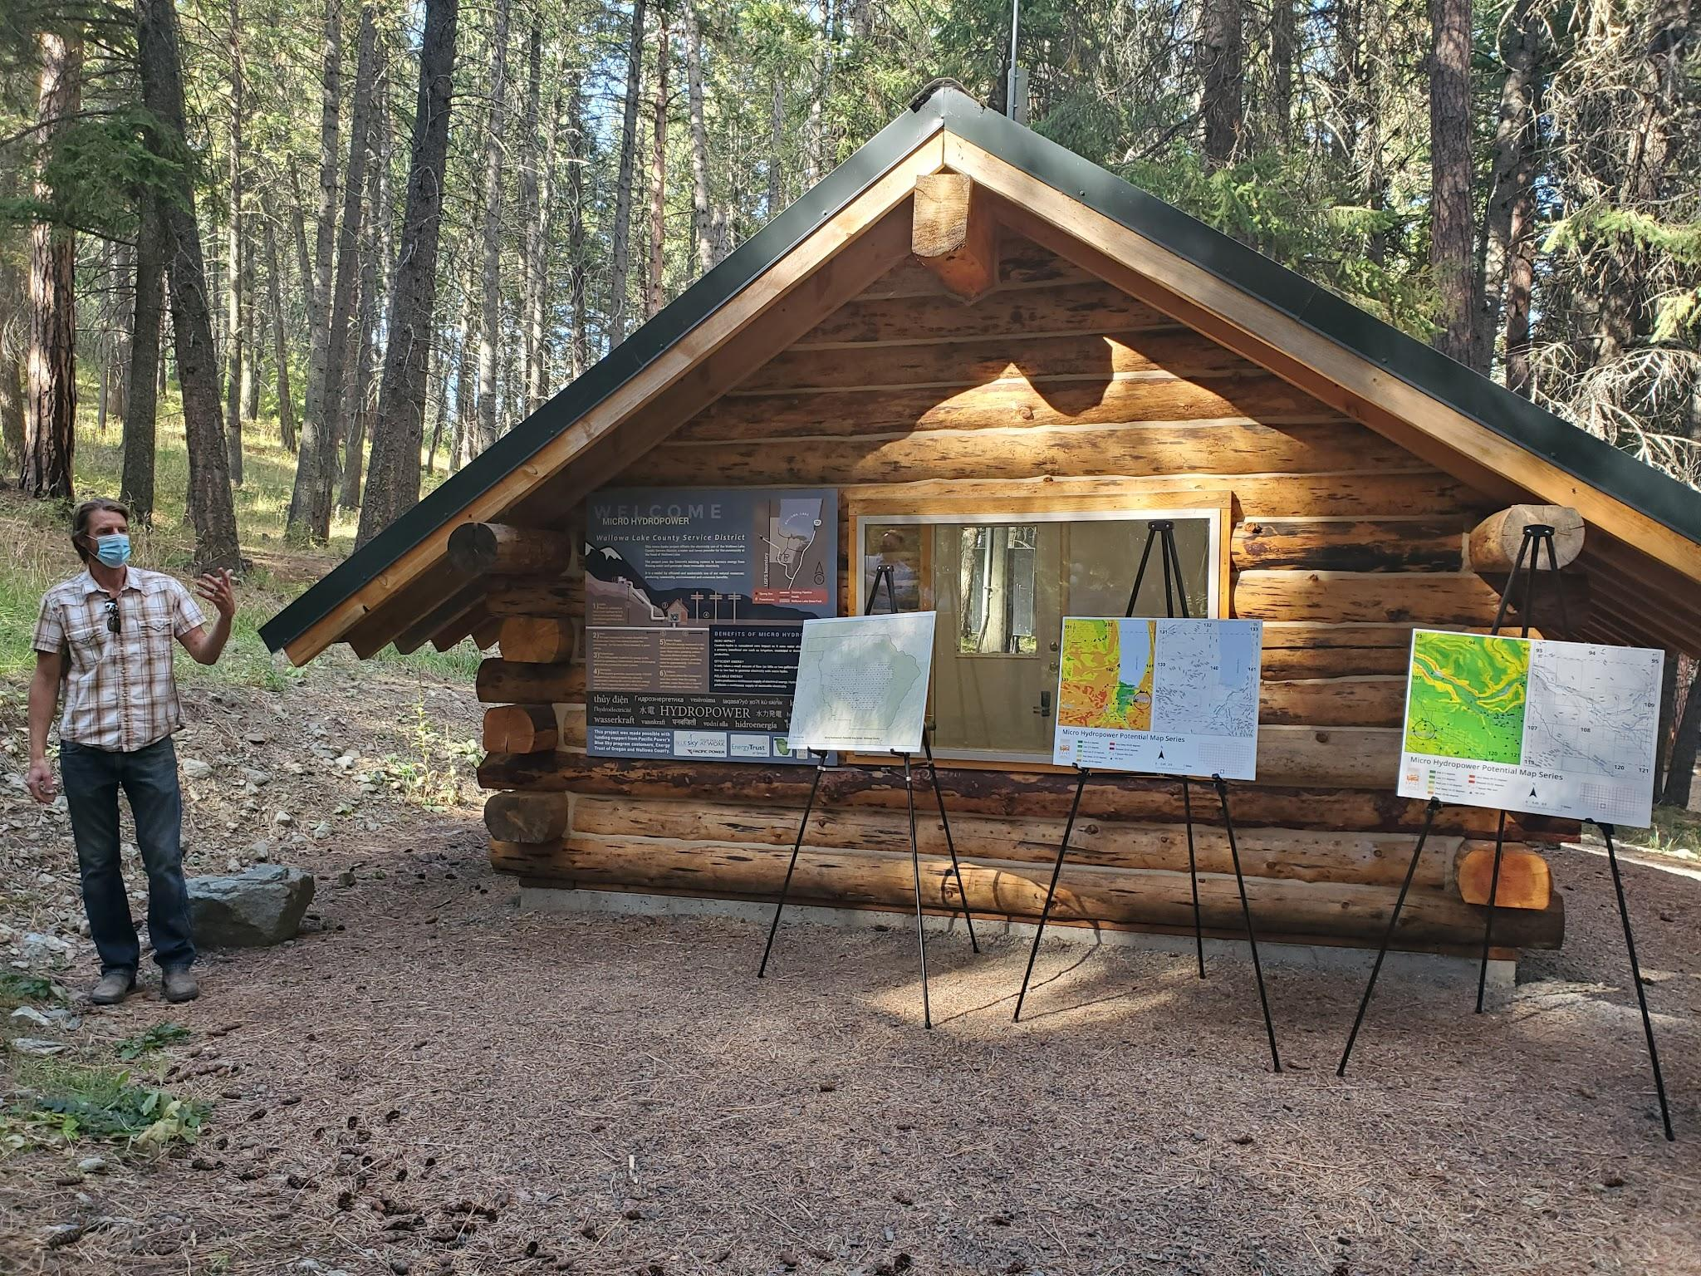
Pacific Power’s Blue Sky customers provided $60,000 in funding to the micro hydro facility as part of its community project grant program, which supports community-based solar, wind, geothermal and renewable energy projects across Pacific Power’s service area. The project also received an $80,000 incentive from Energy Trust.

