Wood Resource Innovation Hub
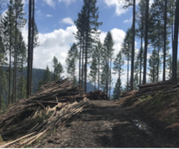
A wood resource processing innovation hub is a facility that processes biomass including hazardous fuels, logging byproducts, and non-timber wood materials like treetops, slash, and small or damaged wood.
A wood processing hub concept builds off of the traditional timber mill model, but instead of depending on a single tree source or end market, different businesses use the same location to create multiple products while sharing costs to purchase, haul and sort non-saw timber and small diameter wood.
Tree tops and damaged logs are often left after timber harvest and burned on the landscape.

The ideal hub serves a 100-mile diameter area using abandoned rural lumber mill sites to process small diameter wood and move it to end markets.
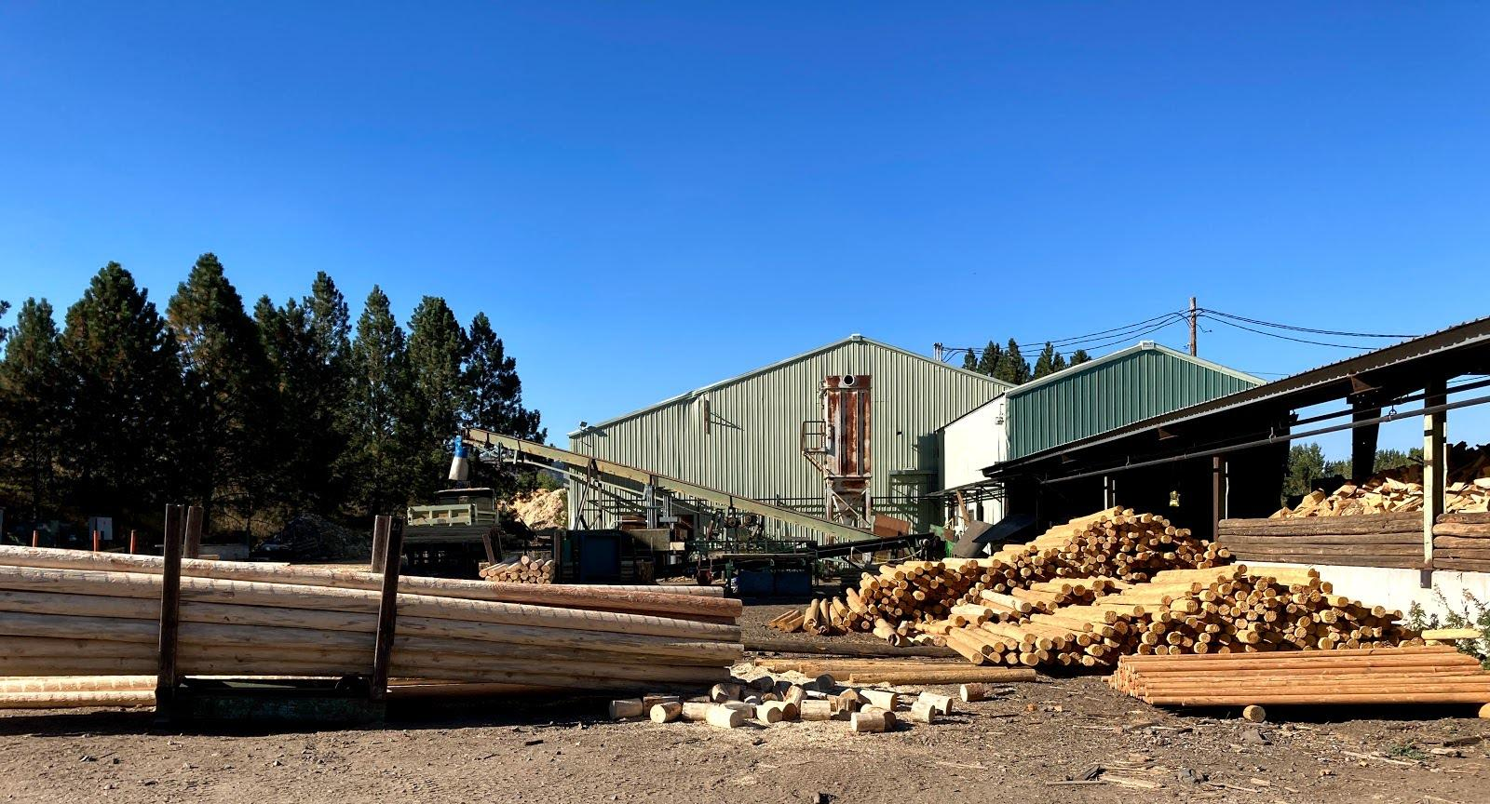
Hubs provide jobs for conversion operators (loggers, truckers, mill workers), and offer biomass products to local end-users.
Another benefit of small diameter wood processing is it helps reduce hazardous fuels and wildfire risk and creates markets for forest restoration byproducts.
The SWFC Committee visited Hartwood Biomass in Wallowa, Oregon to learn about multi-product biomass processing.
MITIGATE WILDFIRE RISK, IMPROVE FOREST HEALTH,
CREATE RURAL JOBS
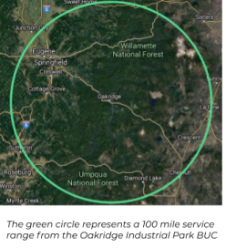
Traditional Small Diameter Wood Products

- Firewood
- Posts and poles
- Woodstraw
Higher-Processing Small Diameter Wood Products
- Wood pellets
- Wood chips
- Building materials
- Biochar - added to soil to increase agricultural production
- Chemicals - e.g., ethanol, plastics components
- Energy - heat, power, or both
Why Oakridge?
- The Oakridge Industrial Park (OIP) is an ideal site for a BUC.
- Oakridge is located in proximity to end markets including population centers in California, Oregon, and Washington, and the I-5 corridor.
- Source wood is within 50 miles of the OIP. Current forestry practices burn biomass as slash.
- Increase capacity to reduce hazardous fuels.
- Job creation.
Local and Regional Support
- Business Oregon
- Lane Workforce Partnership

Active OIP Wood Resource Businesses
Brock’s Wood Lot/ Community Firewood Program – On the Tour
The Community Firewood Program (CFP) is a public-private partnership between the City of Oakridge, South Willamette Solutions (nonprofit), and Brocks Wood Lot LLC (BWL). The CFP has consistently acquired 100-200 CCF of source stock from the Willamette National Forest, Middle Fork Ranger District (MFRD) since 2015. Based on the Oakridge Community and Commercial Firewood Feasibility Study the business potential exists to expand to 3,000 CCF.

Brocks Wood Lot LLC joined the CFP partners in 2023, providing the much needed local entrepreneur who is invested in growing the program and achieving the business opportunity identified in the feasibility study.

Through strategic partnerships, BWL gains access to wood waste from stewardship restoration projects and fire affected areas, positioning the company as a crucial participant in the vital task of mitigating fire hazards. In 2023, 256 CCF (~ 200 cords) of low-value, low-quality, unmerchantable wood, unburned tree tops, and 8 tons of slash and other biomass were collected. In 2024 and moving forward annually, that amount will double to triple in size.

Secured:
2020 - $310,000 from the EPA in 2020 to pay for processing equipment, source stock haul and subsidized firewood delivery ($45,000 remains)
2023 - $25,000 from the Upper Willamette Soil and Water Conservation District for capacity
2024 - $25,000 from the Upper Willamette Soil and Water Conservation District for equipment

Unsecured:
Brocks Wood Lot submitted a $303,830 USDA Wood Infrastructure Program Incentive Grant for:
- $146,100.00 Kiln-Direct SmallQuick Firewood Kiln
  - One Firewood kiln for 12 cords with wood waste heating.
  - Heating system: 900000-150000 btu/hr depending on quality of wood waste material
- $148,850.00 Upgrade to automated wood waste heating
- $5,900.00 Ash removal screw for wood waste powered kiln

Brock’s Wood Lot has submitted a $50,699 USDA Wood Innovations Grant to diversify the products they can offer by purchasing the following:
- $46,090 - LT40HD Sawmill
- $6,995 - MP220 Planer Moulder Rip Saw
- $7,995 - KD250 Dehumidification Wood Kiln

