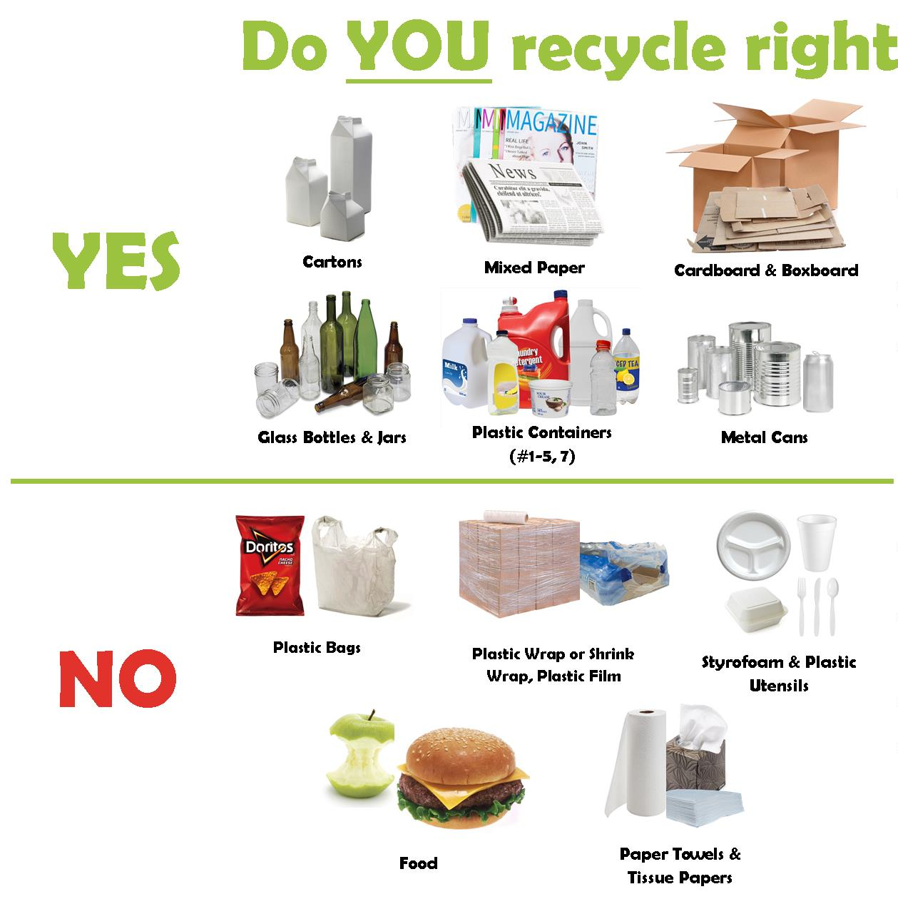

Carboard Flattened
Glass Separated
Pop & Food Cans Rinsed
Plastics Rinsed, No Lids

No Household Garbage
no lids or caps
No waxed cardboard
will not be picked up

ABSOLUTLY NO PLASTIC OF ANY KIND

